Board Meeting 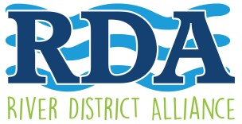
Agenda

February 10, 2020
5:00 pm – Lee County Visitor & Convention Bureau – 2201 Second Street

Thought for the day: “The most important trip you take in life is meeting people Half way”
Henry Boyle

- Call to Order and Welcome, Kevin Boyd, Chairman
- Roll call and approval and minutes - Dannielle Schultz, Secretary
- Financial Report, Merry Coffman, Treasurer
- President & CEO Report, Lisa Sbuttoni
- Committee Reports:
- Special Events – Candice Cocco, Vice Chair and Committee Chair
- Comments or discussion

Adjourn
Next board meeting: March 9, 2020 - VCB offices

