Board Meeting 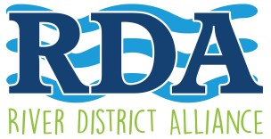
Agenda

November 12, 2019
5:00 pm – Lee County Visitor & Convention Bureau – 2201 Second Street

- Call to Order, Kevin Boyd, Chairman
- Roll call and October’s minutes, Dannielle Schultz, Secretary
- Welcome the Public , Kevin Boyd, Chairman
- Update on Sponsorships, Upcoming Holiday Plans for Downtown, Lisa Sbuttoni, President & CEO
- Financial Report, Merry Coffman, Treasurer
- Membership Updates, Kristin DiIorio, Membership - Chair
- Special Events Committee Update Candice Cocco, Vice -Chair
- Old/New Business: Term Limits
Adjourn
Next meeting: Wednesday, December 11, 2019 Holiday Party Hibiscus House, Time 6: PM {the Holiday Party will replace the Board/General Meeting for December}

www.fortmyersriverdistrictalliance .com Promoting & Enhancing the Development of the Historic River District as a Hub of Economic, Social, and Cultural Activity.

