Board Meeting 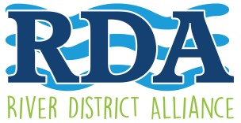
Monday January 13, 2020
5:00 pm – Lee County Visitor & Convention Bureau – 2201 Second Street

- Call to Order, Kevin Boyd, Chairman
- Roll Call and November Minutes, Dannielle Schultz, Secretary
- Welcome & Updates, Kevin Boyd, Chairman
- President Report, and Upcoming Special Events Lisa Sbuttoni, President & CEO
- Financial Report, Distributed
- Public Comments
Adjourn
Next meeting: Feb 10. 2020

www.fortmyersriverdistrictalliance .com Promoting & Enhancing the Development of the Historic River District as a Hub of Economic, Social, and Cultural Activity.

