**Board of Directors**  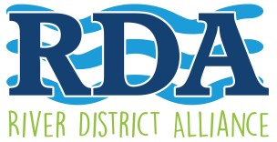

|  |  |  |
| --- | --- | --- |
| Agenda |  |  |

**August 13, 2018**

**Board Workshop: 4:00 pm – 1st floor Green Room**

**General Meeting: 5:00 pm – 1st floor Green Room**

**Lee County Visitor & Convention Bureau – 2201 Second Street**

General Meeting:

1. Call to Order & Roll, Danielle Schultz
2. Approval of the July General Meeting Minutes, Danielle Schultz
3. Welcome, new President and CEO, Lisa Sbuttoni, thank you to search committee members; Kevin Boyd
4. Financial Update, Merry Coffman
5. President and CEO report, Lisa Sbuttoni
6. Events; July 4th, upcoming Veteran’s Day Parade, 10th Anniversary Art Walk, Candace Cocco; Downtown Holidays, Lisa Sbuttoni
7. Bylaw revisions, Merry Coffman
8. Nominating committee, Candace Cocco
9. Membership/Social Media, Barbara Perez and Kristin DiIorio
10. Old/New Business

Adjourn Next meeting: Board meeting, September 10, 4 p.m., VCB offices; Annual meeting, September 24, 5 p.m., VCB offices

www.fortmyersriverdistrictalliance .com

Promoting & Enhancing the Development of the Historic River District as a Hub of Economic, Social, and Cultural Activity.