Board Meeting 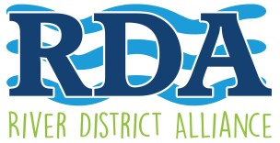
Agenda

September 16, 2019
5:00 pm – Lee County Visitor & Convention Bureau – 2201 Second Street

- Call to Order and Welcome, Kevin Boyd, Chairman
- Roll call and approval and minutes - Dannielle Schultz, Secretary
- Financial Report, Merry Coffman, Treasurer
- President & CEO Report, Lisa Sbuttoni
- Committee Reports:
- Membership – Kristin DiIorio, Committee Chair
- Special Events – Candice Cocco, Vice Chair and Committee Chair
- Overview of Candidates and Nominating – Jim Griffith, Committee Chair

- Ballot Results – Lisa Sbuttoni
Adjourn
Next board meeting: October 14th at 5 p.m., VCB offices
Special Events meeting: September 19th at 3:30 p.m., VCB Offices

